Spring JDBC
_____________________________________________________________________

Q. What is spring JDBC?
______________________________________________________________
Spring JDBC or Spring DAO it is used for connect your java application with database application by using spring framework and this is part of spring module built on basis of plain JDBC means internally spring JDBC using API of plain JDBC

Q. Why use Spring JDBC?
_________________________________________________________________
1. Not need to handle the checked exceptions if we work with Plain JDBC we need to handle checked exception compulsory.
2. Spring JDBC Provide central DB configuration by using XML or by using Config class as single tone bean
3. JdbcTemplate help us to provide all DDL and DML Operation
4. Not need to close the connection it is internally manage by JdbcTemplate class.

Steps to work with Spring JDBC
____________________________________________________________________________________

1. Create Maven project
2. Add the Following maven dependencies
a) Spring core
b) Spring context
c) Spring JDBC
d) MYSQL Connector maven dependency
<dependencies>
<!-- https://mvnrepository.com/artifact/org.springframework/spring-core -->
<dependency>
<groupId>org.springframework</groupId>
<artifactId>spring-core</artifactId>
<version>5.3.27</version>
</dependency>
<!-- https://mvnrepository.com/artifact/org.springframework/spring-context -->
<dependency>
<groupId>org.springframework</groupId>
<artifactId>spring-context</artifactId>
<version>5.3.27</version>
</dependency>
<!-- https://mvnrepository.com/artifact/org.springframework/spring-jdbc -->
<dependency>
<groupId>org.springframework</groupId>
<artifactId>spring-jdbc</artifactId>
<version>5.3.27</version>
</dependency>
<!-- https://mvnrepository.com/artifact/mysql/mysql-connector-java -->
<dependency>
<groupId>mysql</groupId>
<artifactId>mysql-connector-java</artifactId>
<version>8.0.28</version>
</dependency>
</dependencies>

3. Create XML file and Config Database Credential or using annotation also.
_____________________________________________________________________
If we want to configure database credential using spring JDBC we have inbuilt class name as
DriverManagerDataSource from org.springframework.jdbc.core.datasource package
so we need to configure its bean and it four setter method for configure database credential

conn.xml
<?xml version="1.0" encoding="UTF-8"?>
<!DOCTYPE beans PUBLIC "-//SPRING//DTD BEAN 2.0//EN"
"https://www.springframework.org/dtd/spring-beans-2.0.dtd">
<beans>
<bean id="conn" class="org.springframework.jdbc.datasource.DriverManagerDataSource">
<property name="username" value="root"/>
<property name="password" value="root"/>
<property name="url" value="jdbc:mysql://localhost:3306/mysql"/>
<property name="driverClassName" value="com.mysql.cj.jdbc.Driver"/>
</bean>
</beans>
Once we configure Database using XML you can Create client application and check your database is connected or not
Example:
package org.techhub;
import org.springframework.context.ConfigurableApplicationContext;
import org.springframework.context.support.ClassPathXmlApplicationContext;
import org.springframework.jdbc.datasource.DriverManagerDataSource;
public class ClientApplication {
public static void main(String x[]) {
ConfigurableApplicationContext context= new ClassPathXmlApplicationContext("conn.xml");
DriverManagerDataSource dataSource=(DriverManagerDataSource)context.getBean("dataSource");
if(dataSource!=null) {
System.out.println("Database is connected");
}
else {
System.out.println("Database is not connected");
}
}
}
Output:
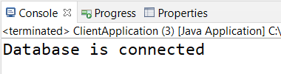
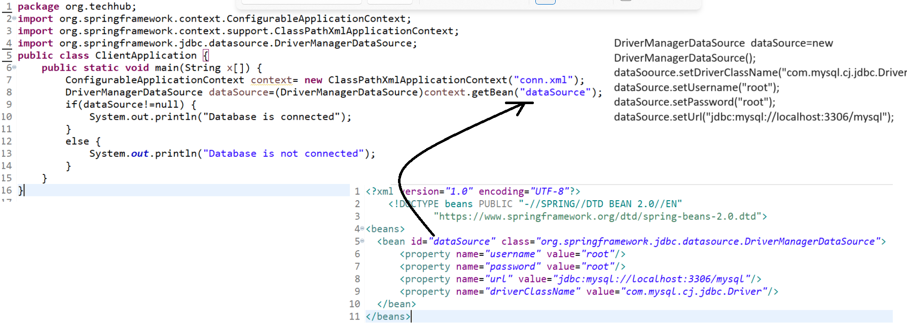

You can configure database credential by using annotations means you can create bean for DriverManagerDataSource class shown in following code.

Example database connection using annotation
package org.techhub.dbconfig.annot;

import org.springframework.context.annotation.Bean;
import org.springframework.context.annotation.Configuration;
import org.springframework.jdbc.datasource.DriverManagerDataSource;

@Configuration
public class DBConfig {
@Bean(name="dataSource")
public DriverManagerDataSource getDataSource() {
DriverManagerDataSource dataSource= new DriverManagerDataSource();
dataSource.setDriverClassName("com.mysql.cj.jdbc.Driver");
dataSource.setUsername("root");
dataSource.setPassword("root");
dataSource.setUrl("jdbc:mysql://localhost:3306/mysql");
return dataSource;
}
}
ClientApplication.java
____________________________________________________________________
package org.techhub.dbconfig.annot;
import org.springframework.context.annotation.AnnotationConfigApplicationContext;
import org.springframework.jdbc.datasource.DriverManagerDataSource;
public class DBConfigClientApplication {
public static void main(String[] args) {
AnnotationConfigApplicationContext context=new AnnotationConfigApplicationContext(DBConfig.class);
DriverManagerDataSource dataSource=(DriverManagerDataSource)context.getBean("dataSource");
if(dataSource!=null) {
System.out.println("Database is connected");
}
else {
System.out.println("Some problem is there..............");
}
}

}

4. Configure bean of JdbcTemplate
___________________________________________________________________________
JdbcTemplate is used for perform all DDL and DML operation on database like as PreparedStatement and JdbcTemplate and DriverManagerDataSource work with object dependency means JdbcTemplate class is dependent on DriverManagerDataSource object.
Means we need to call DriverManagerDataSource bean id from JdbcTemplate.

JdbcTemplate configuration by using XML
______________________________________________________________________________
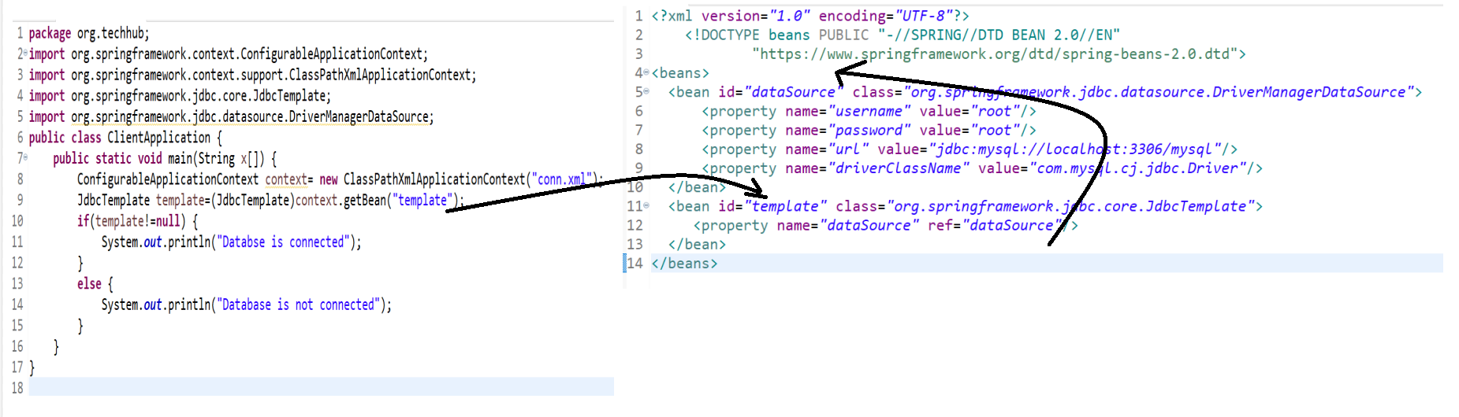
Source code of above diagram
<?xml version="1.0" encoding="UTF-8"?>
<!DOCTYPE beans PUBLIC "-//SPRING//DTD BEAN 2.0//EN"
"https://www.springframework.org/dtd/spring-beans-2.0.dtd">
<beans>
<bean id="dataSource" class="org.springframework.jdbc.datasource.DriverManagerDataSource">
<property name="username" value="root"/>
<property name="password" value="root"/>
<property name="url" value="jdbc:mysql://localhost:3306/mysql"/>
<property name="driverClassName" value="com.mysql.cj.jdbc.Driver"/>
</bean>
<bean id="template" class="org.springframework.jdbc.core.JdbcTemplate">
<property name="dataSource" ref="dataSource"/>
</bean>
</beans>

ClientApplication.java
package org.techhub;
import org.springframework.context.ConfigurableApplicationContext;
import org.springframework.context.support.ClassPathXmlApplicationContext;
import org.springframework.jdbc.core.JdbcTemplate;
import org.springframework.jdbc.datasource.DriverManagerDataSource;
public class ClientApplication {
public static void main(String x[]) {
ConfigurableApplicationContext context= new ClassPathXmlApplicationContext("conn.xml");
JdbcTemplate template=(JdbcTemplate)context.getBean("template");
if(template!=null) {
System.out.println("Databse is connected");
}
else {
System.out.println("Database is not connected");
}
}
}

Configuration of JdbcTemplate by using annotation
___________________________________________________________________________
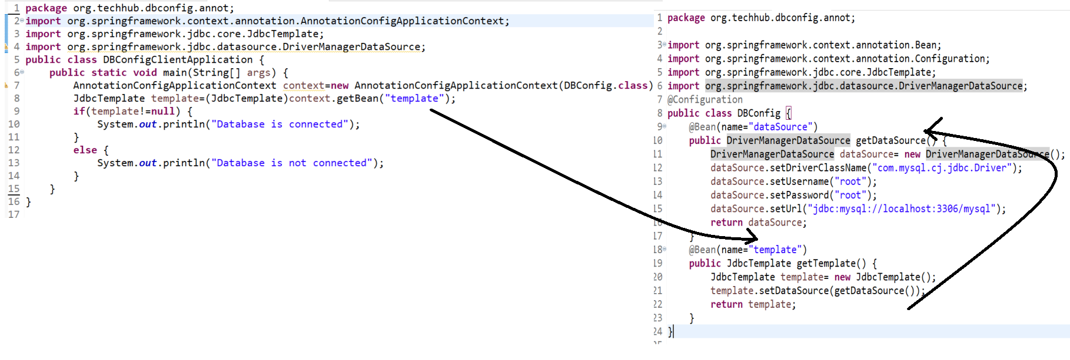
Source code
DBConfig.java
package org.techhub.dbconfig.annot;

import org.springframework.context.annotation.Bean;
import org.springframework.context.annotation.Configuration;
import org.springframework.jdbc.core.JdbcTemplate;
import org.springframework.jdbc.datasource.DriverManagerDataSource;
@Configuration
public class DBConfig {
@Bean(name="dataSource")
public DriverManagerDataSource getDataSource() {
DriverManagerDataSource dataSource= new DriverManagerDataSource();
dataSource.setDriverClassName("com.mysql.cj.jdbc.Driver");
dataSource.setUsername("root");
dataSource.setPassword("root");
dataSource.setUrl("jdbc:mysql://localhost:3306/mysql");
return dataSource;
}
@Bean(name="template")
public JdbcTemplate getTemplate() {
JdbcTemplate template= new JdbcTemplate();
template.setDataSource(getDataSource());
return template;
}
}
DBConfigClientApplication.java
package org.techhub.dbconfig.annot;
import org.springframework.context.annotation.AnnotationConfigApplicationContext;
import org.springframework.jdbc.core.JdbcTemplate;
import org.springframework.jdbc.datasource.DriverManagerDataSource;
public class DBConfigClientApplication {
public static void main(String[] args) {
AnnotationConfigApplicationContext context=new AnnotationConfigApplicationContext(DBConfig.class);
JdbcTemplate template=(JdbcTemplate)context.getBean("template");
if(template!=null) {
System.out.println("Database is connected");
}
else {
System.out.println("Database is not connected");
}
}
}

5. Work with Database: if we want to perform any database operation like as DDL or DML we have JdbcTemplate class and JdbcTemplate class provide some inbuilt method to us for work with database

void execute(String sqlStatement): this method can perform all DDL and DML operation except select.
int update(String sqlStatement,PreparedStatementSetter): this method can execute the all DDL and DML operation except select and use for execute dynamic query and if operation get executed successfully return 1 otherwise return 0.
int update(String sqlStatement,Object []):this method can execute the all DDL and DML operation except select and use for execute dynamic query and if operation get executed successfully return 1 otherwise return 0.

List query(String selectStatement,RowMapper): this method can execute the select without parameter or where clause
List query(String selectStatement,PreparedStatementSetter,RowMapper): this method can execute the select statement with where clause or parameter.

Example: we want to create Spring JDBC program for insert record in table name as marchspringjdbc
package org.techhub.dbconfig.annot;
import org.springframework.context.annotation.AnnotationConfigApplicationContext;
import org.springframework.jdbc.core.JdbcTemplate;
import org.springframework.jdbc.datasource.DriverManagerDataSource;
public class DBConfigClientApplication {
public static void main(String[] args) {
AnnotationConfigApplicationContext context=new AnnotationConfigApplicationContext(DBConfig.class);
JdbcTemplate template=(JdbcTemplate)context.getBean("template");
if(template!=null) {
System.out.println("Database is connected");
template.execute("insert into marchspringjdbc values('ram','ram@gmail.com','1234567')");
System.out.println("Record save Success.................");
}
else {
System.out.println("Database is not connected");
}
}
}
Output:
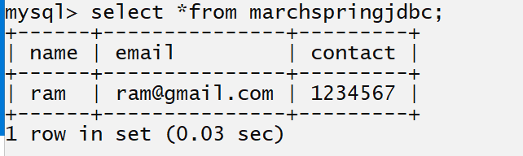

Example: we want to accept name email and contact from keyboard and store in database table.
package org.techhub.dbconfig.annot;
import org.springframework.context.annotation.AnnotationConfigApplicationContext;
import org.springframework.jdbc.core.JdbcTemplate;
import org.springframework.jdbc.datasource.DriverManagerDataSource;
import java.util.*;
public class DBConfigClientApplication {
public static void main(String[] args) {
AnnotationConfigApplicationContext context=new AnnotationConfigApplicationContext(DBConfig.class);
JdbcTemplate template=(JdbcTemplate)context.getBean("template");
if(template!=null) {
System.out.println("Database is connected");
Scanner xyz =new Scanner(System.in);
System.out.println("Enter name email and contact");
String name=xyz.nextLine();
String email=xyz.nextLine();
String contact=xyz.nextLine();
template.execute("insert into marchspringjdbc values('"+name+"','"+email+"','"+contact+"')");
System.out.println("Record save Success.................");
}
else {
System.out.println("Database is not connected");
}
}
}

int update(String sqlStatement,PreparedStatementSetter): this method is used for pass sql statement as well as pass run time parameter to SQL Statement
PreparedStatementSetter is a functional interface so you can use it by using lambda expression or by using anonymous inner class.

Example using Anonymous inner class
package org.techhub;
import org.springframework.context.ConfigurableApplicationContext;

import java.sql.PreparedStatement;
import java.sql.SQLException;
import java.util.*;
import org.springframework.context.support.ClassPathXmlApplicationContext;
import org.springframework.jdbc.core.JdbcTemplate;
import org.springframework.jdbc.core.PreparedStatementSetter;
import org.springframework.jdbc.datasource.DriverManagerDataSource;
public class ClientApplication {
public static void main(String x[]) {
ConfigurableApplicationContext context= new ClassPathXmlApplicationContext("conn.xml");
JdbcTemplate template=(JdbcTemplate)context.getBean("template");
if(template!=null) {
System.out.println("Databse is connected");
System.out.println("Enter name email and contact");
Scanner xyz = new Scanner(System.in);
final String name=xyz.nextLine();
final String email=xyz.nextLine();
final String contact=xyz.nextLine();
PreparedStatementSetter pstmt=new PreparedStatementSetter() {
public void setValues(PreparedStatement ps) throws SQLException {
ps.setString(1, name);
ps.setString(2,email);
ps.setString(3, contact);
}

};
int value=template.update("insert into marchspringjdbc values(?,?,?)",pstmt);
if(value>0) {
System.out.println("Record Save Success.................");
}
else {
System.out.println("Some problem is there...................");
}
}
else {
System.out.println("Database is not connected");
}
}
}
Example using Lambda expression with PreparedStatementSetter
_________________________________________________________________________
package org.techhub;
import org.springframework.context.ConfigurableApplicationContext;

import java.sql.PreparedStatement;
import java.sql.SQLException;
import java.util.*;
import org.springframework.context.support.ClassPathXmlApplicationContext;
import org.springframework.jdbc.core.JdbcTemplate;
import org.springframework.jdbc.core.PreparedStatementSetter;
import org.springframework.jdbc.datasource.DriverManagerDataSource;
public class ClientApplication {
public static void main(String x[]) {
ConfigurableApplicationContext context= new ClassPathXmlApplicationContext("conn.xml");
JdbcTemplate template=(JdbcTemplate)context.getBean("template");
if(template!=null) {
System.out.println("Databse is connected");
System.out.println("Enter name email and contact");
Scanner xyz = new Scanner(System.in);
final String name=xyz.nextLine();
final String email=xyz.nextLine();
final String contact=xyz.nextLine();
PreparedStatementSetter pstmt=(PreparedStatement ps) ->{
ps.setString(1, name);
ps.setString(2,email);
ps.setString(3, contact);
};
int value=template.update("insert into marchspringjdbc values(?,?,?)",pstmt);
if(value>0) {
System.out.println("Record Save Success.................");
}
else {
System.out.println("Some problem is there...................");
}
}
else {
System.out.println("Database is not connected");
}
}
}
Example using lambda expression
_______________________________________________________________________________
package org.techhub;
import org.springframework.context.ConfigurableApplicationContext;
import java.sql.PreparedStatement;
import java.sql.SQLException;
import java.util.*;
import org.springframework.context.support.ClassPathXmlApplicationContext;
import org.springframework.jdbc.core.JdbcTemplate;
import org.springframework.jdbc.core.PreparedStatementSetter;
import org.springframework.jdbc.datasource.DriverManagerDataSource;
public class ClientApplication {
public static void main(String x[]) {
ConfigurableApplicationContext context= new ClassPathXmlApplicationContext("conn.xml");
JdbcTemplate template=(JdbcTemplate)context.getBean("template");
if(template!=null) {
System.out.println("Databse is connected");
System.out.println("Enter name email and contact");
Scanner xyz = new Scanner(System.in);
final String name=xyz.nextLine();
final String email=xyz.nextLine();
final String contact=xyz.nextLine();

int value=template.update("insert into marchspringjdbc values(?,?,?)",(PreparedStatement ps) ->{
ps.setString(1, name);
ps.setString(2,email);
ps.setString(3, contact);
});
if(value>0) {
System.out.println("Record Save Success.................");
}
else {
System.out.println("Some problem is there...................");
}
}
else {
System.out.println("Database is not connected");
}
}
}

Example Input email and delete from database table using Spring JDBC
____________________________________________________________________________
package org.techhub;

import org.springframework.context.annotation.Bean;
import org.springframework.context.annotation.Configuration;
import org.springframework.jdbc.core.JdbcTemplate;
import org.springframework.jdbc.datasource.DriverManagerDataSource;

@Configuration
public class Config {

@Bean(name="dataSource")
public DriverManagerDataSource getDataSource() {
DriverManagerDataSource dataSource=new DriverManagerDataSource();
dataSource.setDriverClassName("com.mysql.cj.jdbc.Driver");
dataSource.setUsername("root");
dataSource.setPassword("root");
dataSource.setUrl("jdbc:mysql://localhost:3306/mysql");
return dataSource;
}
@Bean(name="template")
public JdbcTemplate getTemplate() {
JdbcTemplate template=new JdbcTemplate(getDataSource());
return template;
}
}
ClientApplication.java
package org.techhub;
import org.springframework.context.annotation.AnnotationConfigApplicationContext;
import org.springframework.jdbc.core.JdbcTemplate;
import org.springframework.jdbc.core.PreparedStatementSetter;
import java.sql.PreparedStatement;
import java.sql.SQLException;
import java.util.*;
public class ClientApplication {
public static void main(String[] args) {
AnnotationConfigApplicationContext context = new AnnotationConfigApplicationContext(Config.class);
JdbcTemplate template = (JdbcTemplate) context.getBean("template");
Scanner xyz = new Scanner(System.in);
System.out.println("Enter email");
final String email = xyz.nextLine();
int value = template.update("delete from marchspringjdbc where email=?", new PreparedStatementSetter() {

public void setValues(PreparedStatement ps) throws SQLException {
ps.setString(1, email);
}

});
if (value > 0) {
System.out.println("Success.................");
} else {
System.out.println("failed....................");
}
}
}

How to select record from database table using spring JDBC
_______________________________________________________________________
If we want to select record from database table using spring JDBC we have query() method

Steps
1. Create POJO class as per the table structure
2. Call the query() method like as
List query(String selectStatement,RowMapper):
String selectStatement: this parameter indicates we can write here select statement.
RowMapper: this is functional interface which is used for fetch data from database table
it contain mapRow(ResultSet rs) this method can fetch single row at time from database table.

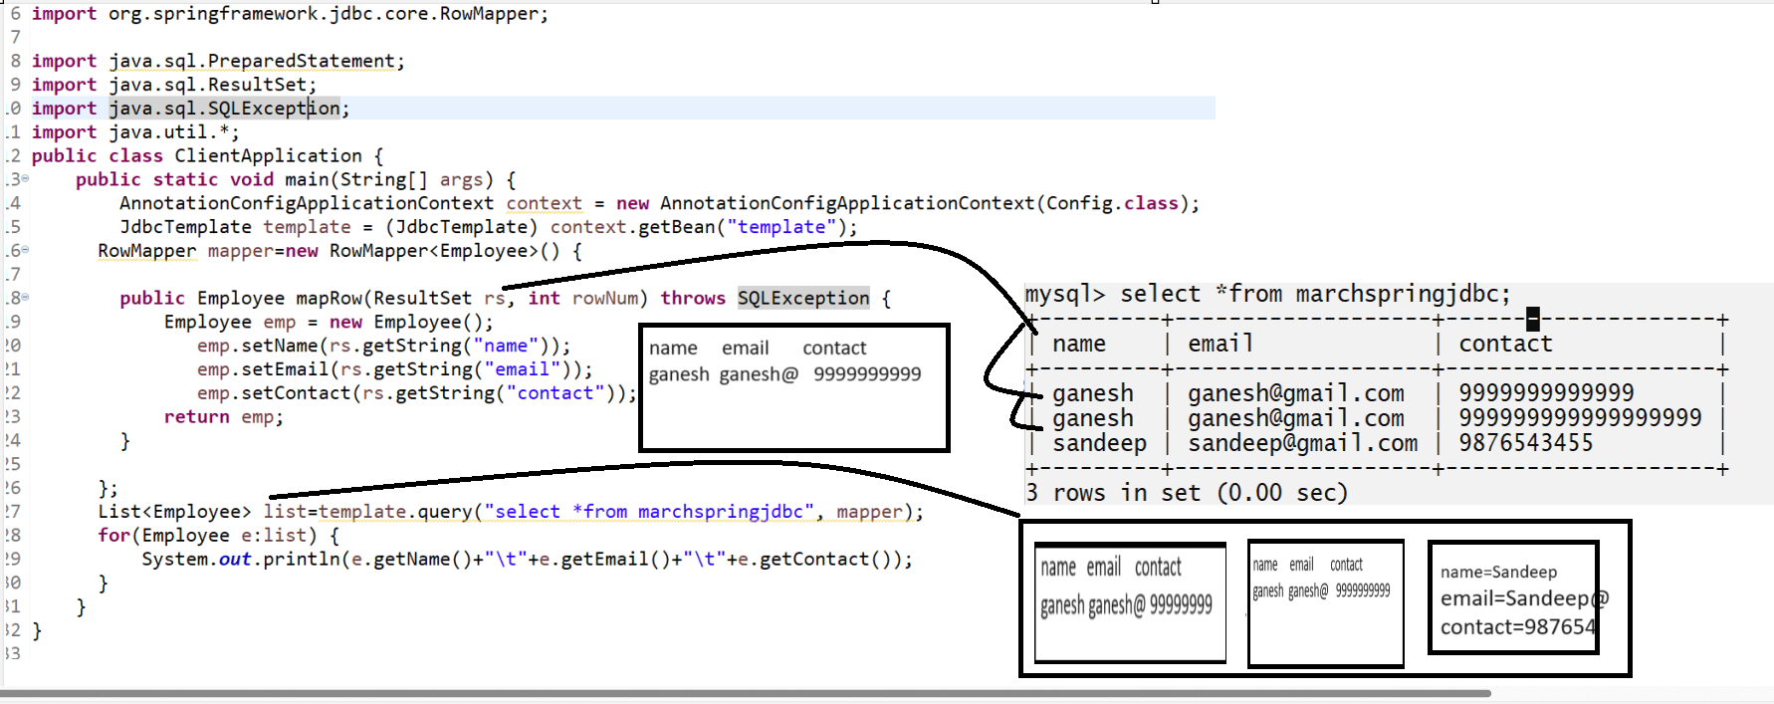
Source code
package org.techhub;
import org.springframework.context.annotation.AnnotationConfigApplicationContext;
import org.springframework.jdbc.core.JdbcTemplate;
import org.springframework.jdbc.core.PreparedStatementSetter;
import org.springframework.jdbc.core.RowMapper;
import java.sql.PreparedStatement;
import java.sql.ResultSet;
import java.sql.SQLException;
import java.util.*;
public class ClientApplication {
public static void main(String[] args) {
AnnotationConfigApplicationContext context = new AnnotationConfigApplicationContext(Config.class);
JdbcTemplate template = (JdbcTemplate) context.getBean("template");
RowMapper mapper=new RowMapper<Employee>() {

public Employee mapRow(ResultSet rs, int rowNum) throws SQLException {
Employee emp = new Employee();
emp.setName(rs.getString("name"));
emp.setEmail(rs.getString("email"));
emp.setContact(rs.getString("contact"));
return emp;
}

};
List<Employee> list=template.query("select *from marchspringjdbc", mapper);
for(Employee e:list) {
System.out.println(e.getName()+"\t"+e.getEmail()+"\t"+e.getContact());
}
}
}

How to fetch particular column from table using Spring JDBC
_____________________________________________________________________________
If we want to fetch particular column from table using Spring JDBC then we create array of Object class and store all columns data in it and store Object array in List Collection.

Example: we want to fetch only name and email from table

package org.techhub;

import org.springframework.context.annotation.AnnotationConfigApplicationContext;
import org.springframework.jdbc.core.JdbcTemplate;
import org.springframework.jdbc.core.PreparedStatementSetter;
import org.springframework.jdbc.core.RowMapper;

import java.sql.PreparedStatement;
import java.sql.ResultSet;
import java.sql.SQLException;
import java.util.*;
public class ClientApplication {
public static void main(String[] args) {
AnnotationConfigApplicationContext context = new AnnotationConfigApplicationContext(Config.class);
JdbcTemplate template = (JdbcTemplate) context.getBean("template");
List<Object[]> list=template.query("select name,email from marchspringjdbc", new RowMapper<Object[]>() {
public Object[] mapRow(ResultSet rs, int rowNum) throws SQLException
{
Object obj[]=new Object[] {rs.getString("name"),rs.getString("email")};
return obj;
}

});
for(Object obj[]:list) {
System.out.println(obj[0]+"\t"+obj[1]);
}
}
}

How to use where clause in select query using Spring JDBC
_____________________________________________________________________________
If we want to pass parameter to select query using where clause we have following syntax of query method.

Syntax: List query(String selectStatement,RowMapper,Object[]):
String selectStatement: this parameter indicate we have select query here
RowMapper: using RowMapper you can fetch data from database table.
Object[]: this is used for pass run time parameter to where clause.
or
List query(String selectStatement PreparedStatementSetter,RowMapper):
String selectStatement: this parameter indicate we have select query here
PreparedStatementSetter: this is used for pass run time parameter to where clause.
RowMapper: using RowMapper you can fetch data from database table.

Example: we want to input email and contact of employee and get its detail.
package org.techhub;
import java.util.*;
import org.springframework.context.annotation.AnnotationConfigApplicationContext;
import org.springframework.jdbc.core.JdbcTemplate;
import org.springframework.jdbc.core.PreparedStatementSetter;
import org.springframework.jdbc.core.RowMapper;

import java.sql.PreparedStatement;
import java.sql.ResultSet;
import java.sql.SQLException;
import java.util.*;
public class ClientApplication {
public static void main(String[] args) {
AnnotationConfigApplicationContext context = new AnnotationConfigApplicationContext(Config.class);
JdbcTemplate template = (JdbcTemplate) context.getBean("template");
Scanner xyz = new Scanner(System.in);
System.out.println("Enter email and contact");
String email=xyz.nextLine();
String contact=xyz.nextLine();
List<Employee> list=template.query("select *from marchspringjdbc where email=? and contact=?",new RowMapper<Employee>() {

public Employee mapRow(ResultSet rs, int rowNum) throws SQLException {
Employee emp1 = new Employee();
emp1.setName(rs.getString("name"));
emp1.setEmail(rs.getString("email"));
emp1.setContact(rs.getString("contact"));
return emp1;
}
},new Object[] {email,contact});
for(Employee e:list) {
System.out.println(e.getName()+"\t"+e.getEmail()+"\t"+e.getContact());
}
}
}

or
package org.techhub;
import java.util.*;
import org.springframework.context.annotation.AnnotationConfigApplicationContext;
import org.springframework.jdbc.core.JdbcTemplate;
import org.springframework.jdbc.core.PreparedStatementSetter;
import org.springframework.jdbc.core.RowMapper;

import java.sql.PreparedStatement;
import java.sql.ResultSet;
import java.sql.SQLException;
import java.util.*;
public class ClientApplication {
public static void main(String[] args) {
AnnotationConfigApplicationContext context = new AnnotationConfigApplicationContext(Config.class);
JdbcTemplate template = (JdbcTemplate) context.getBean("template");
Scanner xyz = new Scanner(System.in);
System.out.println("Enter email and contact");
final String email=xyz.nextLine();
final String contact=xyz.nextLine();
List<Employee> list=template.query("select *from marchspringjdbc where email=? and contact=?",new PreparedStatementSetter() {

public void setValues(PreparedStatement ps) throws SQLException {
// TODO Auto-generated method stub
ps.setString(1,email);
ps.setString(2, contact);
}

},new RowMapper<Employee>() {

public Employee mapRow(ResultSet rs, int rowNum) throws SQLException {
Employee emp1 = new Employee();
emp1.setName(rs.getString("name"));
emp1.setEmail(rs.getString("email"));
emp1.setContact(rs.getString("contact"));
return emp1;
}
});
for(Employee e:list) {
System.out.println(e.getName()+"\t"+e.getEmail()+"\t"+e.getContact());
}
}
}

